Evaluation of SVP-B drifters from an operational point of view

By Pierre Blouch
Centre de Meteorologie Marine de Meteo-France (CNRM/CMM)
13, rue du Chatellier – BP 90411 – 29604 BREST CEDEX - FRANCE

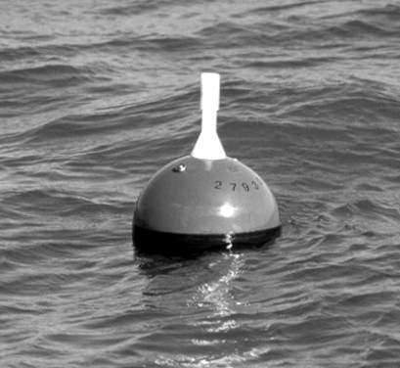
Background
Since FGGE-type buoys are less and less used for operational purposes, SVP-B drifters have been the most common drifting buoys providing air pressure (AP) measurements at the surface of the oceans. What can we globally expect from these drifters ? What is the daily operating cost for air pressure measurements ? What is the frequency of quick failures ? What are the longest lifetimes ? Did the performances vary over the past years ? Is there any difference between drifters deployed by ship or by air ? These are the questions asked by the buoy operators.
Four years ago, an evaluation study, based on the use of buoy QC statistics to assess the AP measurement lifetimes, was performed by CMM (see P. Blouch [1] and [2]). For 230 drifters deployed before May 1996, the mean lifetime for air pressure was about 200 days. It had already been noted that an important number of quick failures, occurred during the deployment, or a few days later, led to reduce the mean lifetime significantly. On the contrary, some drifters had been correctly working during more than 700 days after their deployment, proving that the principle of measurement was good. Manufacturers were invited to improve the reliability of the drifters they produce and buoy operators were requested to take care of the deployments.

Photo 1 – SVP-B drifter
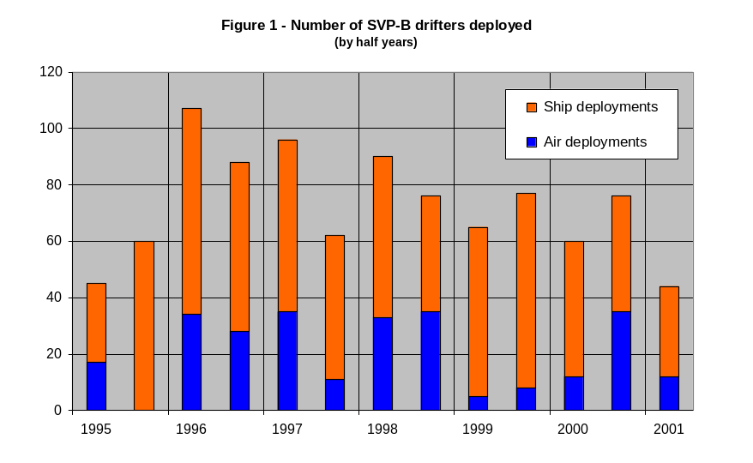
The present study takes stock of the situation after 4 years of new deployments. About 1000 SVP-B drifters, deployed since 1994, have been studied. Figure 1 shows that the total number of deployments seems to decrease since 1996 (167 drifters against 136 in 2000). On average, 28% of the deployments have been done by air.
Figure 2 shows the breakdown of the drifters according to their manufacturers. We mainly notice that, apparently, Clearwater provided a few SVP-B drifters only to buoy operators, after 1998.
Evaluation method
The method used to evaluate the performances has been unchanged since 1996-98. It is based on the monthly statistics of the differences between observations and weather forecasting model outputs. A drifter is declared to have its AP measurements out of order during a specific month when the percentage of “gross errors” is higher than 5%, when the bias is higher than 5 hPa or when the standard deviation of differences is higher than 3 hPa. The end of measurements may also be the date of beaching (even if the buoy continues to report correct values), or the end of the transmission. The presence or the absence of the drogue isn’t taken in account in AP lifetime computations.
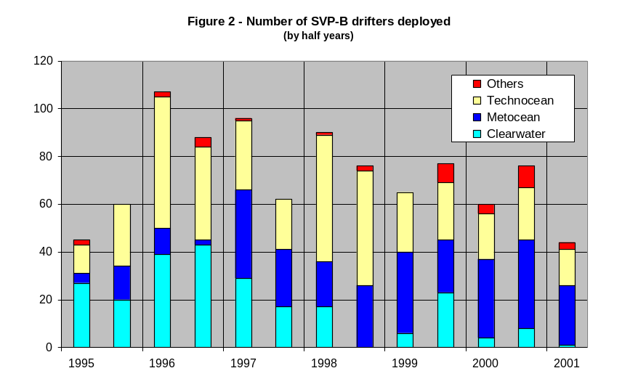
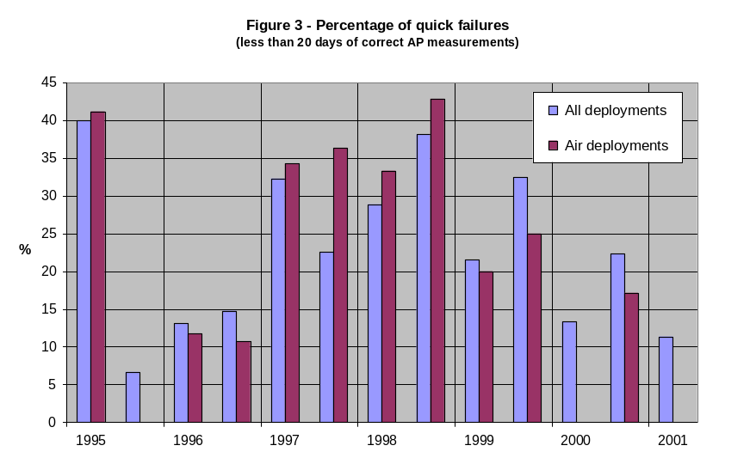
Quick failures
For some buoys, the data never appeared onto the GTS. This could be due to mistakes in the deployment log (buoy not really deployed or having no barometer), to the GTS technical file which wasn’t updated or to the drifter which wasn’t activated. However, most of the time, it should be due to a failure during the deployment. For an operational point of view, all cases must be taken in account.
The quick failures are determined as being occurred during the deployment or less than 20 days later. It includes the drifters for which no data appeared onto the GTS. As shown in figure 3, the percentage of quick failures increased until the end of 1998 (about 40%) before decreasing. It’s interesting to note that the percentage of quick failures doesn’t seem to be related to the way of deployment (air or ship). Although there were no air deployments during the second half part of 1995, there were no quick failures for air deployments during the second half parts of 2000 and 2001.

 | Clearwater |  |  | Metocean |  |  | Technocean |  |  | Others |  |  | Total
 | Total | Failed | % | Total | Failed | % | Total | Failed | % | Total | Failed | % | Total | Failed | %
1995/1 | 27 | 11 | 41 | 4 | 1 |  | 12 | 5 | 42 | 2 | 1 |  | 45 | 18 | 40
1995/2 | 20 | 1 | 5 | 14 | 0 | 0 | 26 | 3 | 12 | 0 | 0 |  | 60 | 4 | 7
1996/1 | 39 | 4 | 10 | 11 | 3 | 27 | 55 | 6 | 11 | 2 | 1 |  | 107 | 14 | 13
1996/2 | 43 | 7 | 16 | 2 | 1 |  | 39 | 4 | 10 | 4 | 1 |  | 88 | 13 | 15
1997/1 | 29 | 13 | 45 | 37 | 4 | 11 | 29 | 14 | 48 | 1 | 0 |  | 96 | 31 | 32
1997/2 | 17 | 6 | 35 | 24 | 1 | 4 | 21 | 7 | 33 | 0 | 0 |  | 62 | 14 | 23
1998/1 | 17 | 5 | 29 | 19 | 0 | 0 | 53 | 20 | 38 | 1 | 1 |  | 90 | 26 | 29
1998/2 | 0 | 0 |  | 26 | 3 | 12 | 48 | 24 | 50 | 2 | 2 |  | 76 | 29 | 38
1999/1 | 6 | 3 |  | 34 | 3 | 9 | 25 | 8 | 32 | 0 | 0 |  | 65 | 14 | 22
1999/2 | 23 | 14 | 61 | 22 | 2 | 9 | 24 | 8 | 33 | 8 | 1 |  | 77 | 25 | 32
2000/1 | 4 | 3 |  | 33 | 3 | 9 | 19 | 2 | 11 | 4 | 0 |  | 60 | 8 | 13
2000/2 | 8 | 4 |  | 37 | 7 | 19 | 22 | 4 | 18 | 9 | 2 |  | 76 | 17 | 22
2001/1 | 1 | 1 |  | 25 | 2 | 8 | 15 | 0 | 0 | 3 | 2 |  | 44 | 5 | 11
Total | 234 | 72 | 31 | 288 | 30 | 10 | 388 | 105 | 27 | 36 | 11 | 31 | 946 | 218 | 23
Table 1 – Percentage of quick failures according to buoy manufacturers
(percentages higher than 20% are in bold)
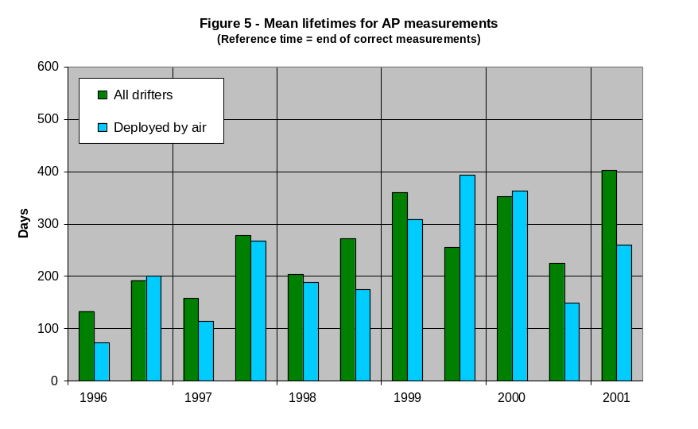
On table 1, we can see that, in 1997-99, the quick failures on SVP-B drifters mainly occurred for two manufacturers : Clearwater and Technocean. Apparently, the problem was solved for buoys deployed after 1999 but Clearwater stopped (or reduced) its production.
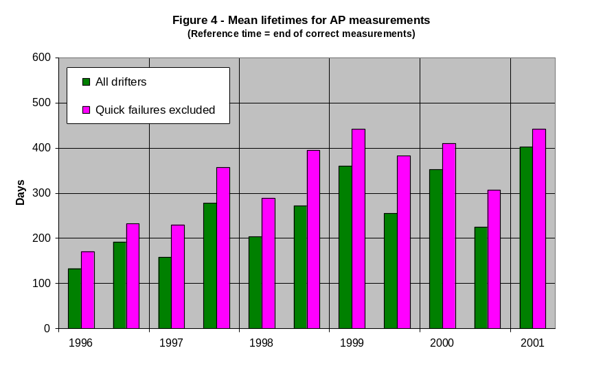
Mean lifetimes
Figure 4 shows the mean lifetimes for air pressure measurements since 1996. The ends of life are used to share the buoys and to compute their mean lifetimes over 6-months periods.
Apparently, the mean lifetime for air pressure measurements increased until the beginning of 1999. It seems more or less stable (about 400 days), if we don’t take in account the quick failures and the second half part of 2000.
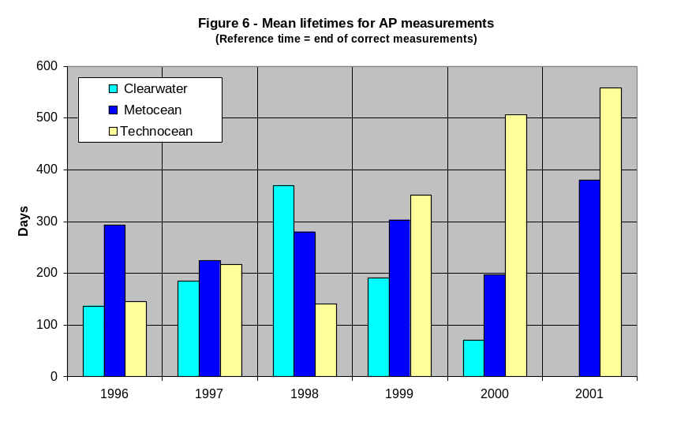
As for the quick failures, the measurement lifetimes don’t seem to be related to the way of deployment. Figure 5 shows the total mean lifetimes (i.e. quick failures included) for all drifters and those deployed by air. Some differences appear but they can be due to wrong series rather than specific problems with the way of deployment. For instance, the mean lifetime for buoys deployed by air was significantly lower than this of all buoys which ceased working during the second half of 1998 and the first half of 2001. On the contrary, it was higher at the end of 1999.
It must be noted that, when a problem happens, it concerns a lot of buoys at the same time. Thus, the bad performances occurred during the second part of 2000, are mainly due to a batch of 20 drifters built by Metocean and deployed by air. 65% of these drifters failed less than 120 days after their deployment although only 15% of them had a quick failure. On the contrary, 87% of the 24 buoys provided to the South African Weather Bureau by the same manufacturer at the beginning of 1997, had their lifetime higher than 550 days.
Figure 6 shows the variation of mean lifetimes (quick failures included) according to buoy manufacturers. No significant value was available for Clearwater in 2001. We can see : a significant increase of the lifetimes for drifters provided by Technocean since 1998 (140 days only against 560 in 2001) ; an increase of the lifetimes for Metocean if we remove the drifters which ceased working in 2000 (from 220 days in 1997 to 380 days in 2001) ; an increase, then a decrease for Clearwater. However, these performances must be moderated. Actually, some SVP-B drifters which failed over the recent years worked 1/3 of the time only. Because they spent less energy, their lifetimes were naturally higher than for those which worked full time.
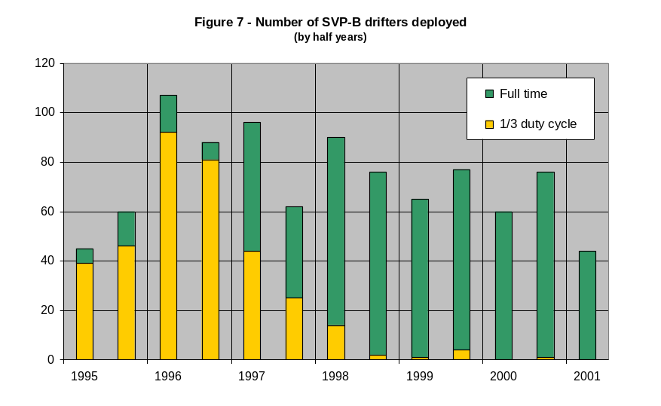
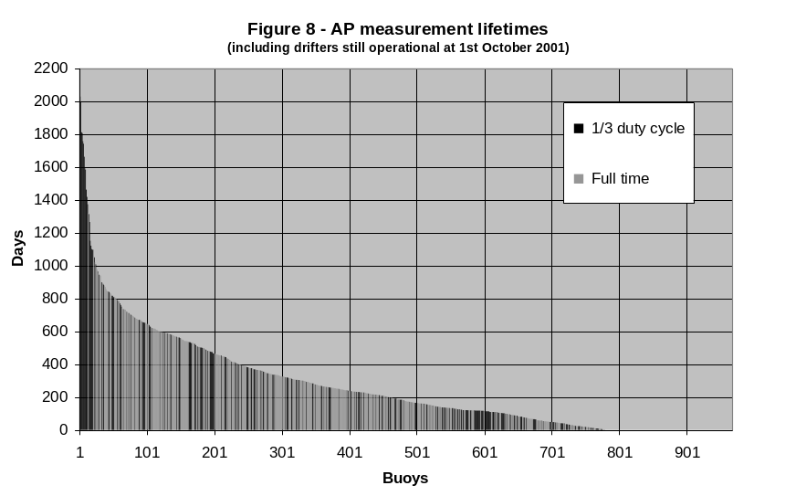
Highest lifetimes
Figure 7 shows the number of buoys deployed since 1995, according to their duty cycle. Figure 8 represents the AP lifetimes for these drifters, including those which are still in operation on October 1st, 2001. It’s obvious that the best performances were obtained by drifters having the 1/3 duty cycle. Twenty-two drifters of that kind had a lifetime higher than 1000 days whereas only 3 ones working full time had.

The good performances of drifters having the 1/3 duty cycle artificially increase the mean lifetimes when they cease working. To correct this artefact, the measurement lifetimes were limited to 2.5 years (913 days) and the mean lifetime computations was redone.

WMO | Argos | Deploy. time | Ocean (deployment) | End time | End bias | Lifetime (days) | Remark
46561 | 24443 | 13/01/96 | North Pacific | Still alive* | -4 hPa | 2087 | Stayed in N-Pacific
33906 | 22095 | 02/10/94 | South Atlantic | 20/04/00 | -2 hPa | 2027 | Loop in Indian O.
56607 | 25792 | 13/04/96 | Indian Ocean | Still alive* | +1 hPa | 1996 | Stayed in Indian O.
15905 | 16615 | 12/10/96 | South Atlantic | 26/09/01 | 0 hPa | 1810 | Stayed in S-Atlantic
46915 | 16593 | 12/06/96 | North Pacific | 22/05/01 | +1 hPa | 1805 | Stayed in N-Pacific
Table 2 – Characteristics of 5 SVP-B drifters having their lifetime higher than 1800 days (~5 years)
All were built by Technocean and work(ed) 1/3 of the time
(*) at October 1st, 2001
Figure 9 shows the trajectory of SVP-B drifter 22095 (WMO 33906) which was deployed in South Atlantic. Pushed in the Indian Ocean by the roaring Forties, it came back in South Atlantic after having done a loop at lower latitudes (~25°S). It stopped transmitting five years and a half after its deployment although it was drifting towards its starting position. It had lost its drogue in March 1996 although it was drifting in the Indian Ocean.

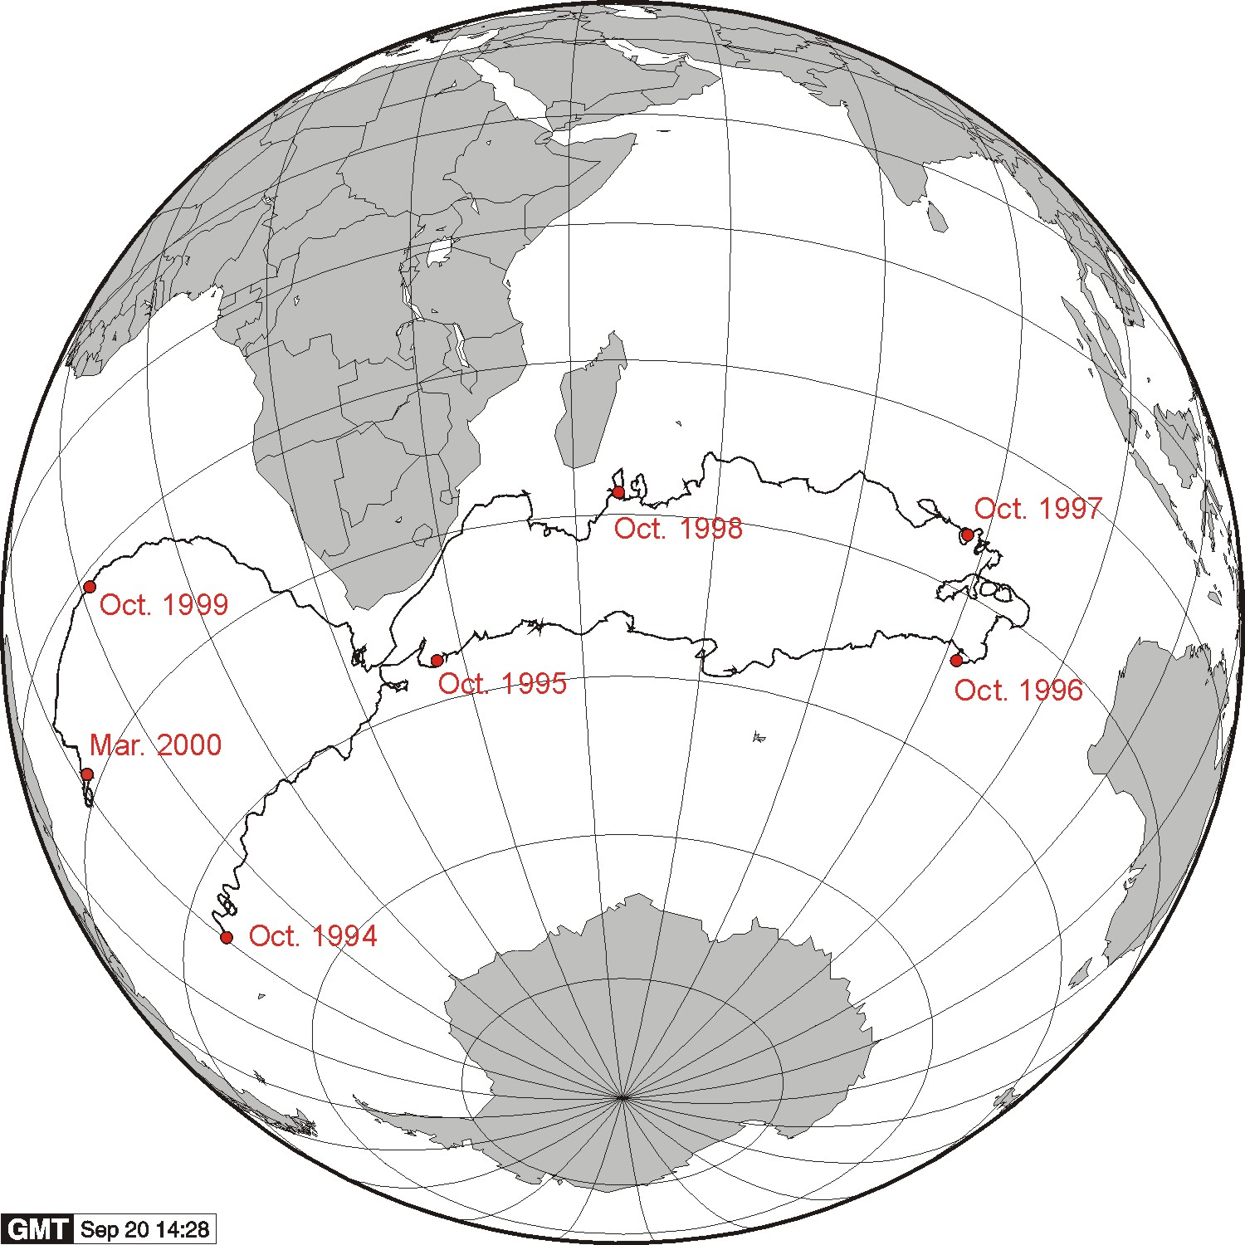
Figure 9 – SVP-B drifter trajectory
Argos 22095 - WMO 33906
Owned by NOAA/AOML
Built by Technocean

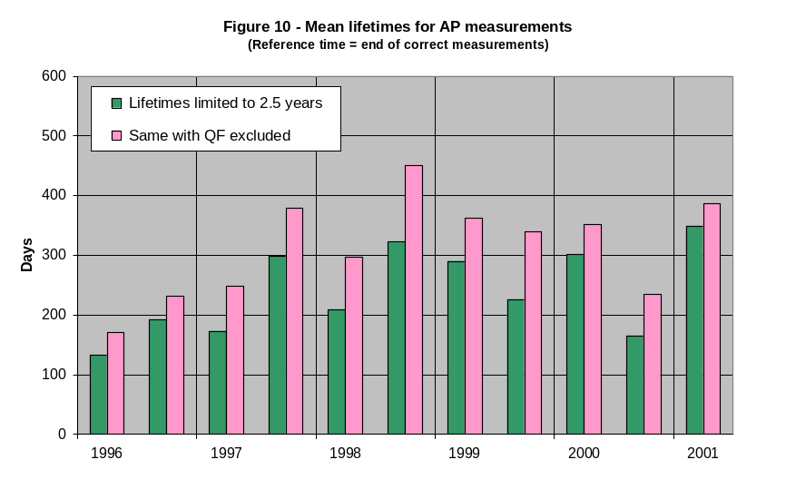

Corrected mean lifetimes
Figure 10 shows the mean lifetimes after limitation of the individual lives to 2.5 years. The average has been about 380 days since the end of 1998, if we don’t take in account the quick failures and the second half part of 2000. It has been about 300 days when the quick failures were included.
With the 2.5 years limitation, the average lifetimes (quick failures included) fall down from 500 and 550 days to about 380-400 days for Technocean drifters which ceased working in 2000 and 2001 (see figure 11). These durations are similar to the one obtained for Metocean drifters deployed in 2001. Moreover, the performances obtained by the two manufacturers have been more or less the same since 1997, excepted in 2000 when Metocean met some problems as indicated above.
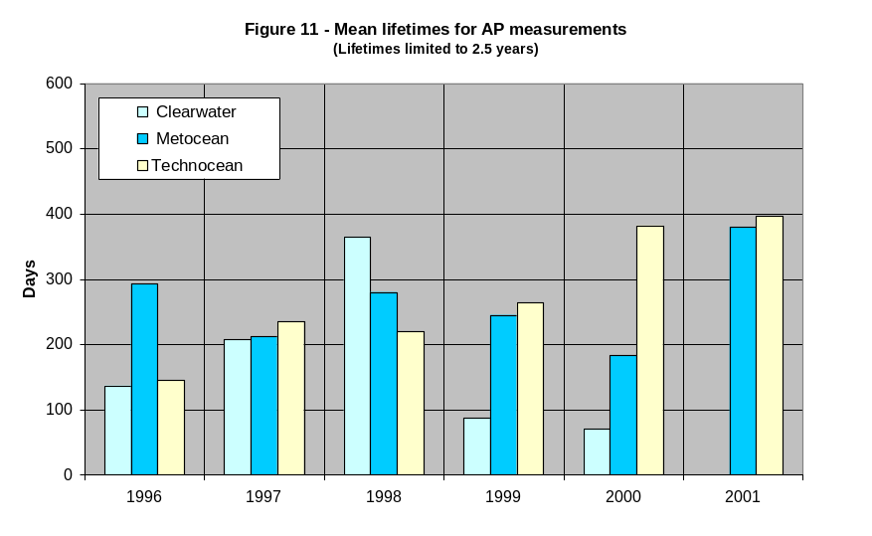
Operating costs
According to recent purchases carried out by Meteo-France in 2001, the price for one SVP-B drifter is about 3,850 euro, including delivery to the centre of deployment. Assuming that the average lifetime is now about 390 days and that the Argos transmission costs 11 euro per day if no bonus is available, the total daily operating cost per buoy is about 21 euro for air pressure measurements. Notice that most of the buoys now provide hourly data.
Conclusions
- The number of SVP-B drifters deployed each year has been regularly decreasing since 1996 ;
- The performances of SVP-B drifters are generally independent on the way of deployment (ship or aircraft) ;

- The percentage of quick failures has been decreasing since it reached a maximum in 1998 ;
- Some SVP-B drifters provided reliable air pressure data during more than 5 years, proving that the principle is good ;
- The mean lifetime for air pressure measurements has been more or less stable since 1999 : about 300 days after correction due to the fact that early buoys worked 1/3 of the time only (quick failures included) ;
- Two manufacturers (Metocean and Technocean) provided SVP-B drifters which ceased working in 2001, about 390 days on average after their deployment (quick failures included) ;
- According to these performances, we can say that the operating cost for air pressure measurements is presently about 21 euros, Argos transmission included ;
- Problems still occur from time to time on drifter series (e.g. Metocean drifters deployed in 2000 in the South Atlantic). These problems must be avoided thanks to better quality checks performed at manufacturers.

References
[1] Blouch P., 1997 : The quality control of buoy data transmitted on the GTS and its use in evaluating the SVP-B drifter, Developments in buoy and telecommunication technologies, Data Buoy Co-operation Panel Technical Document, 10, 17-22.
[2] Blouch P., J. Rolland, 1998 : Evolution of the performances of air pressure measurements on the SVP-B drifter, Developments in buoy technology and data applications, Data Buoy Co-operation Panel Technical Document, 12, 39-42.

FGGE : First Global GARP (Global Atmosphere Research Programme) Experiment

